## Introduction

This device is intended for users with arthritis that have difficulty typing due to joint pain. The ball of the device provides an easy grip, while the stylus allows for the user to type.

## Features

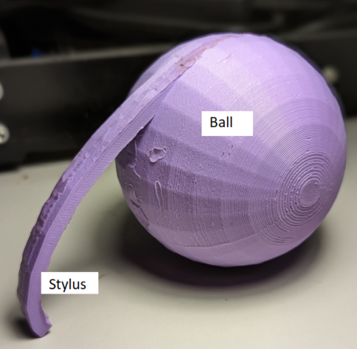

## Usage

To use, hold the ball of the device in your hand like a tennis ball, and use the attached stylus to press the buttons on the keyboard.

## Compatibility

The device is compatible with any keyboard that has force based buttons. It will not work with a capacitive keyboard.

## Specifications

Ball diameter: 78 mm

Stylus length: 100mm

Device weight: 86g

## Cleaning

The device can be wiped clean with a damp cloth.